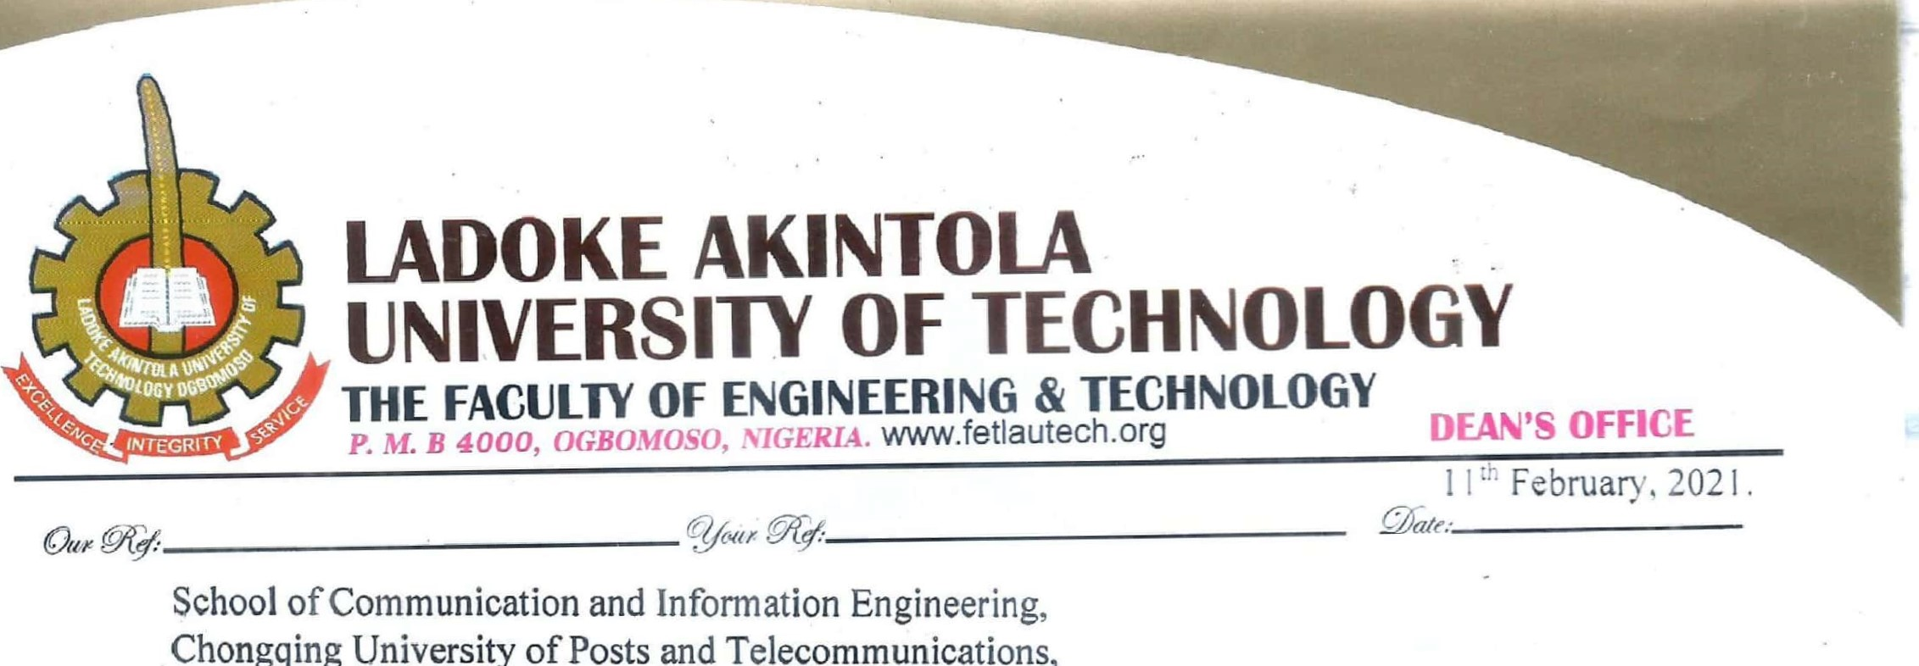

of

Posts

and

Manchester Metropolitan University,

All Saints Building,

Manchester.

M15 6BH

United Kingdom.

Dear Sir/Madam,

# LETTER OF RECOMMENDATION: FABOWALE, JOHNSON TAIWO

It is with great pleasure that I am writing this letter to endorse the application of Mr. FABOWALE Johnson Taiwo to your university. My relation with Johnson started in 2010 as one of my undergraduate students in Electronic and Electrical Engineering department. I recognized his full strength of conscientiousness and smartness, two most essential qualities that make a genuine Engineer.

During the course of his undergraduate studies here in the department, he was a diligent student who always accomplished task assigned to him successfully. I highly evaluated his research skills and I believe he can work and deliver with minimum supervision. He had showed an impressive desire to be a good researcher and his practical and logical approach to handling various challenges in life is astonishing.

Mr. FABOWALE Johnson Taiwo has sound English Language proficiency to undertake quality research in his chosen area of interest, having been taught and assessed in English Language throughout his undergraduate days.

Based upon my assessment of the applicant's ability and academic performance with diligence in achieving any desired objectives, I believe without doubt that Mr. FABOWALE Johnson Taiwo will perform excellently in his Master programme and further in life.

I strongly recommend him for Master Degree in Engineering Smart Systems in your highly reputable University without any reservation.

Please if there is any further detail you would like to known about this candidate, kindly contact me by email or call.

Yours Sincerely,

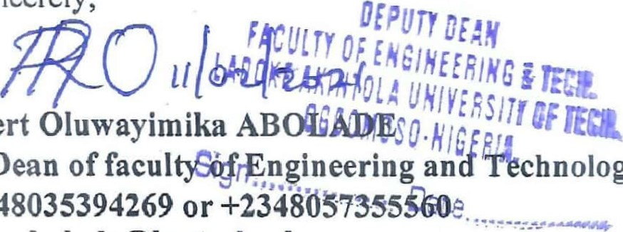

Dr.

Robert ABOLADE

Deputy

Dean Faculty Engineering and Technology/Associate Professor

Tel: +2348035394269 or +2348057355560

Email: roabolade@lautech.edu.ng